Samtse Higher Secondary School
Samtse Dzongkhag

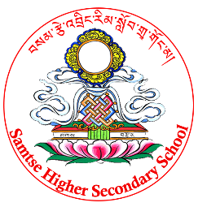
Project work on
“Effects of salt water on the plant”

Name: Yeshi Dorji
Class: XII
Section: SCI A
2017
Tutor: Mrs. Yeshey Dema
Subject: Biology

